Prince of Peace: Time & Talent Survey
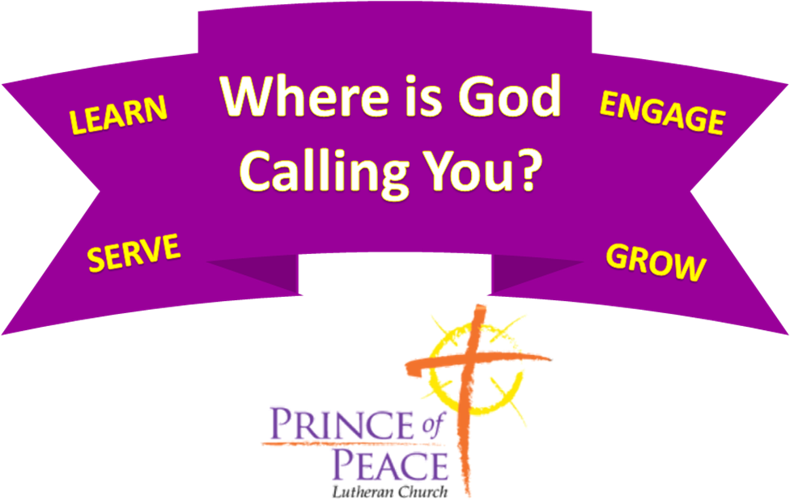

Name: | Preferred Phone:  Alternate Phone:
Street Address: | City, State, Zip:
Email: | Occupation:  Service hour you most often attend:
Thank you for supporting Prince of Peace and its ministries through sharing your time and talents!
Check any box in which you are interested in either learning more about or serving. We would also appreciate completing answers to the questions at the end. All information on these sheets will remain confidential among church staff and leadership.
- I am interested in serving in the following area(s):
Teaching & Education:  Sunday School Teacher/Helper:  - Preschool (birth - 4 years old)  - Grade School (grades K-5)  - Middle School (grades 6-8)  - Substitute Teacher  - High School (grades 9-12)  - Young Adult  - Adults  - Bible Study  Youth Activities:  - Chaperoning events  - Mentoring youth  - Coordinating youth events  Caring Ministries:  - Pastoral Partners  - Caring Connections  - Eucharistic Ministers  - Blossom Hill Ministry  - Comfort Quilters  - Prayer Chain Ministry | Social Ministry:  - OMNI (Orphan Medical Network International)  - God’s Work, Our Hands  - Habitat for Humanity  - Lorain County Foodbank  - ELCA World Hunger  - Love, INC  - Providence House  - Women’s Domestic Violence Center  - Chaplain Partnership  - Christmas Mitten Tree  - School Supplies for Scranton  - Box Tops & Soup Labels for Scranton  Lutheran Metropolitan Ministry  - LMM Men’s Shelter meals  - Boots for Christmas  - LMM Next Step  - LMM Women’s Re-Entry | Worship & Music:  - Greeter  - Usher  - Altar Guild  - Communion Assistant  - Assisting Minister (layperson)  - Prayer Leader  - Lesson Reader  - Music (instrument): _________  Handbells___ Handchimes__  - Music (vocal)  - Visual Display Operator  - Sound Board Operator  Outreach/Evangelism:  - Open Mic Night  - Parade participation  - Marketing/Publicity  Property & Finance:  - Property upkeep  - Financial planning of POP  Other Service Areas:  - Mission volunteer  - POP Leadership Position
PLEASE see the POP website for further details about each opportunity above. https://www.princeofpeacewestlake.org/by-laws-documents Annual Report
- I have a passion for and/or interest in the following area(s):
- Baking/Cooking  - Building things  - Counting (numbers, money)  - Crafting/Decorating  - Encouraging others  - Event planning  - Fitness  - Giving financially  - Leading or facilitating teams/groups  - Listening to others | - Making others welcome  - Making phone calls  - Providing compassionate care  - Recruiting others  - Sharing the Gospel with others  - Storytelling  - Technology  - Social Media  - Infrastructure & Security  - Web design  - Travel  - Writing | Counseling & Support:  - Divorced  - Married Couples  - Single Parents  - Blended Families  - Singles  - Widows/Widowers  - Crisis Counseling  - Aging Parents  - Child Development
- I would like to serve the community and individuals in the area(s) of:
- Adoption/Foster Care  - AIDS  - Alzheimer's/Dementia  - Alcohol & Drug Addictions  - Blood Drives  - Children with Special Needs  - Clothes Pantry  - Crisis Pregnancy | - Deaf Ministry  - Disaster Relief  - Ethnic/Cultural Diversity  - Grief Care  - Homelessness  - Human Sexuality & Gender Acceptance  - Loneliness | - Mental Health Issues  - Nursing Home Ministry  - Physical Abuse  - Physical Handicaps/Health Issues  - Prison Ministry  - Other: ___________________
- I can serve the church and community through personal skills and talents in:
Construction/Repair:  - AC/Furnace Repair  - Cabinetry/Furniture Repair  - Electrical  - Flooring  - Heavy Lifting  - Landscaping/Lawn Care  - Painting  - Plumbing  - Roofing  - Vehicle Repairs & Upkeep | Arts:  - Acting  - Artwork/Drawing  - Computer Graphics  - Crafts  - Dance  - Floral Arranging  - Photography/Videography  - Puppetry  - Sewing/Quilting/Costumes  - Staging/Props | Education:  - English as 2nd Language  - Mathematics/Reading  - Teaching/Tutoring  Miscellaneous:  - Accounting  - Childcare  - Driving/Transportation  - Food Preparation  - General Housekeeping  - Insurance
- I am available:
- Mornings  - Afternoons  - Evenings  - Weekdays  - Weekends  - Will need to schedule | - Sunday  - Monday  - Tuesday  - Wednesday  - Thursday  - Friday  - Saturday | - One Time Projects  - Short Term Projects  - At Home Projects  - Long Term Projects  - As Needed
- Are there any other gifts or interests that you are interested in sharing but they have not been identified? Please share:

